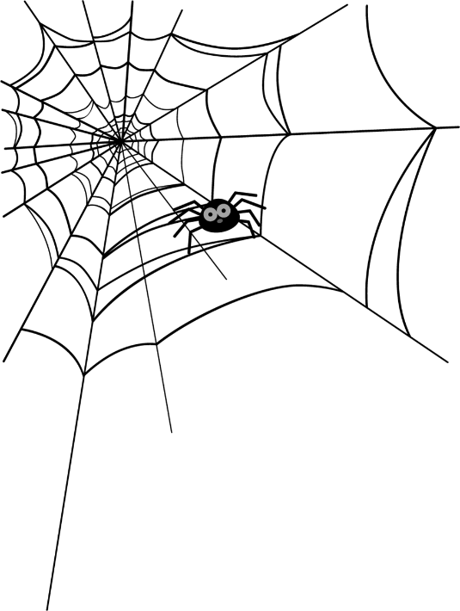
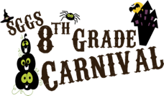
Dear 8TH Grade Parents and Students,
It is hard to believe that it is time for the Carnival. Our students have been working hard to prepare everything. If they would like to order a snack for the day, please fill out the sheet below.
In addition, students can purchase tickets for the raffle by using this form. Advance sales will take place October 7th-20th. No cash is handled by our 8th graders during the carnival. Students and teachers MUST pre-pay for food items and unlimited game and activity access.
$1.00 for Cotton Candy, Popcorn and Soda
$2.00 for Soft Pretzel
$1.00 for Raffle Tickets - winners will be announced at the end of the day.
Please complete the order form below and return it to the school with your payment in the form of a check payable to SGGS or cash in the EXACT AMOUNT only. We cannot make change and overage is considered a donation. If you write one check for more than one child, please make sure you fill out an order form for EACH child and reference the check number. There will be a $30.00 fee on all returned checks.
Thank you very much for your support of the 8th Grade Carnival! Please cut off and return the form below by October 20th at the latest.
PLEASE USE ONE FORM PER CHILD. YOU CAN WRITE ONE CHECK BUT EACH CHILD NEEDS A SEPARATE FORM.

Student’s Name: __________________________________ Grade: ________
Homeroom Teacher: Robertson Room #: 203
ITEM | How Many? |  | Cost per Item |  | Total Cost
Soda |  | x | $1.00 | = | $
Soft Pretzel |  | x | $2.00 | = | $
Cotton Candy |  | x | $1.00 | = | $
Popcorn |  | x | $1.00 | = | $
Raffle Tickets |  | x | $1.00 | = | $
 | Total Amount of Order |  |  |  | $

